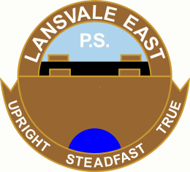 | Lansvale East Public School  Riverside Road, Lansvale Nsw 2166  Tel: 9728 1278 Fax: 9728 2339  Abn: 62 007 935 117  Email: lansvalee-p.school@det.nsw.edu.au  Web: www.lansvalee-p.schools.nsw.edu.au

UNIFORM PRICE LIST
as at 27th August 2018
ITEM | PRICE
Polo Shirt (Short) | $25.00
Polo Shirt (Long) | $30.00
Short (Male) | $15.00
Skort (Female) | $15.00
Jacket | $25.00
4391Cap (Blue) | $15.00
Hat (Blue) | $15.00
Pants (Male) | $20.00
Pants (Female) | $20.00
Dress | $45.00
Sport Uniform | $35.00
Sport Shorts | $15.00
Sport Shirt | $20.00
Track Suit | $70.00
Track Suit Jacket | $40.00
Track Suit Pants | $30.00
School Bag | $35.00
Library Bag | $15.00
Excursion Bag | $15.00

