Community News
June
2018
Term 2 Week 9

Upcoming Dates
Monday 2nd July Reports go home Car park renovations commence
Tuesday 3rd July – School Excursion – Taronga Zoo
Wednday 4th July – Parent-Teacher Interviews
Friday 6th July Whole School Assembly Last day of term – Term Three commences for students on Tuesday 17th July
Tuesday 7th August - Multicultural Day
Thursday 9th August - Education Open Day
Principal Corner!
It has been a busy few weeks at Lansvale East Public School! Students have been doing amazing work inside and outside the classrooms. I visited 1/2Responsible this week, where I had the opportunity to read and discuss the text Sam and Dave Dig a Hole. The students loved listening to the book and sharing their thoughts via a whole class discussion. The students then constructed a written response from ideas in the text. They wrote about their predictions of the characters’ actions.
Teachers have been busy writing students’ Semester One reports. These reports provide you with information relating to your child’s

achievements in all Key Learning Areas this Semester and items they are working on to further enhance their learning. You will be provided with the opportunity to discuss this report at the parent-teacher interviews.
A big thank you to the P&C for organising the ‘Footy Colours’ day, where the students had the opportunity to wear the colours of their favourite football team, donate a coin for the Year Six Farewell and purchase a yummy lunch pack from the canteen. The students had lots of fun!
Parent-teacher Interviews
You would have received a note regarding parent-teacher interviews. These interviews are a great opportunity for you to discuss your child’s progress, ask any questions and learn more about their future goals. Please complete the slip and return to your child’s teacher as soon as possible. Whilst your pick for a time may not be able to be given, every effort will be made to ensure the closet time possible. Interviews are for 10 minutes, if you require a longer time, arrangements can be made after the interview.
Attendance
We all want our students to get a great education, and the building blocks for a great education begin with students coming to school each and every day. If students miss school regularly, they miss out on learning the fundamental skills that will set them up for success in the later years of school. There is no safe number of days for missing school – each day a student misses puts them behind, and can affect their educational outcomes. There are always times when students need to miss school, such as when they’re ill. It’s vital that they’re only away on the days they are sick, and setting good sleep patterns, eating well and exercising regularly can make a big difference. If you’re having attendance concerns with your child, please let your classroom teacher or myself know so we can work together to get your child to school every day.
Regional Cross Country
Brooke and Bradely represented Lansvale East PS with pride last week at the Regional Cross Country at Hurlstone Agricultural High School. It is an amzaing achievment to represent the school and Region at this level. Congratualtions!
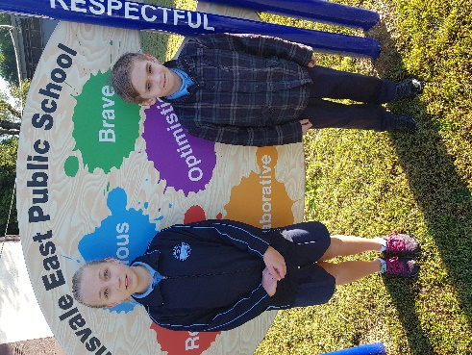

Learner Qualities in the Classroom
During 2018, we are embedding our new, 3R core values (Respectful, Responsible and Resilient) and our 5 learner qualities (Optimistic, Brave, Curious, Reflective and Collaborative). We would like to share what being curious means to the students.
Curious – To show an interest in learning more about a range of different things. This interest may lead to an investigation or inquiry. Being curious will enhance knowledge and skill development for all! We can encourage children to be curious through asking questions and encouraging them to read and explore!

Carpark Construction Works
As of the 3rd July, the staff carpark will be closed due to renovations. A new roundabout and path is being constructed for assisted travel cars entering the school carpark to pick up and drop off students. Staff will be entering the school through the Jupiter Street entry. For our families entering the gate from Jupiter Street, please ensure the path is used at all times to ensure the safety of everyone.

Parent Technology Workshop
The parent technology workshop ran last week was a great success. Thank you to the lovely parents who joined us! Parents enjoyed learning about the free Microsoft programs and applications and gained some cool new tricks. These included read aloud functions and adding animations to photos. We look forward to seeing our parents at the next workshop. Thank you to Mrs Haggett for organising this event!
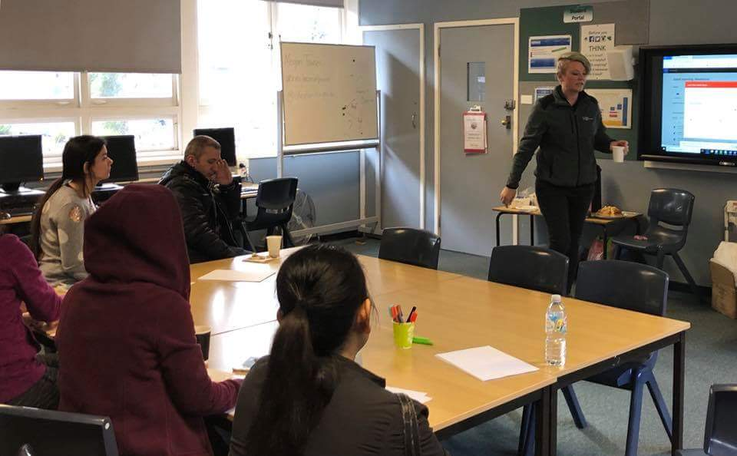

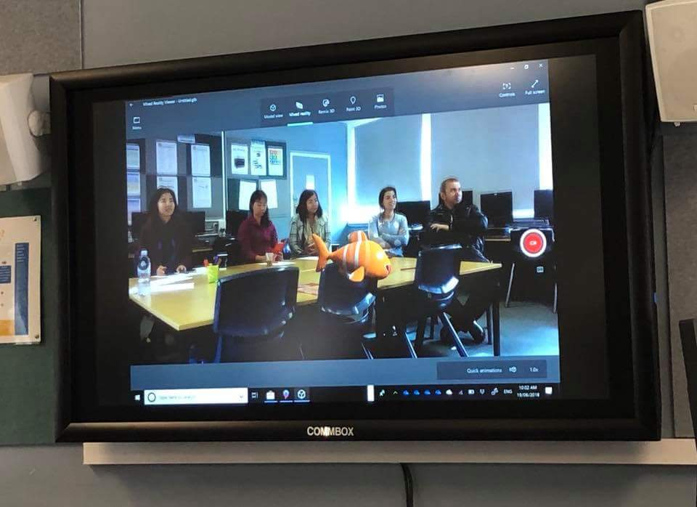

Lansvale East P&C Facebook Page
The Lansvale East P&C have created a Facebook page for our community. This page will provide current information relating to the P&C, including updates on activities, events and fundraisers. Please join up to get regular updates and information about how to become involved. To do this, search for Lansvale East P&C in the search engine of Facebook and click to join the group!

Save the date!
Term Three sees us celerbarte Education Week. We have an exciting week planned with Multicultural Day (7th August) and Open Day (9th August). We would love for you to join in with the celerbartions. More information will follow shortly!

1/2 Respectful – Class Visit Photos
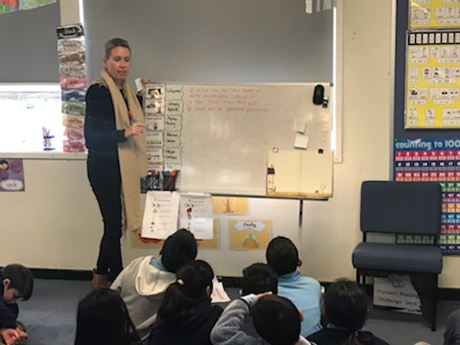

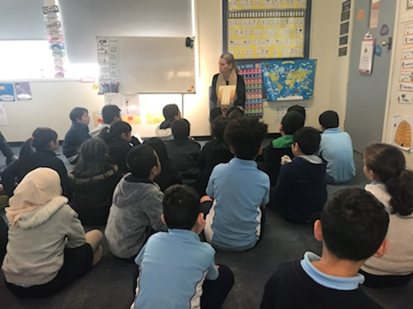

Camp Time!
There are still a number of limited spaces available for students wishing to attend the Great Aussie Bush Camp from 29th-30th October. The cost is $285. Notes are available at the office if needed.

Have a wonderful holiday with family and friends. Stay safe!
Miss Nicole Cameron
Relieving Principal

