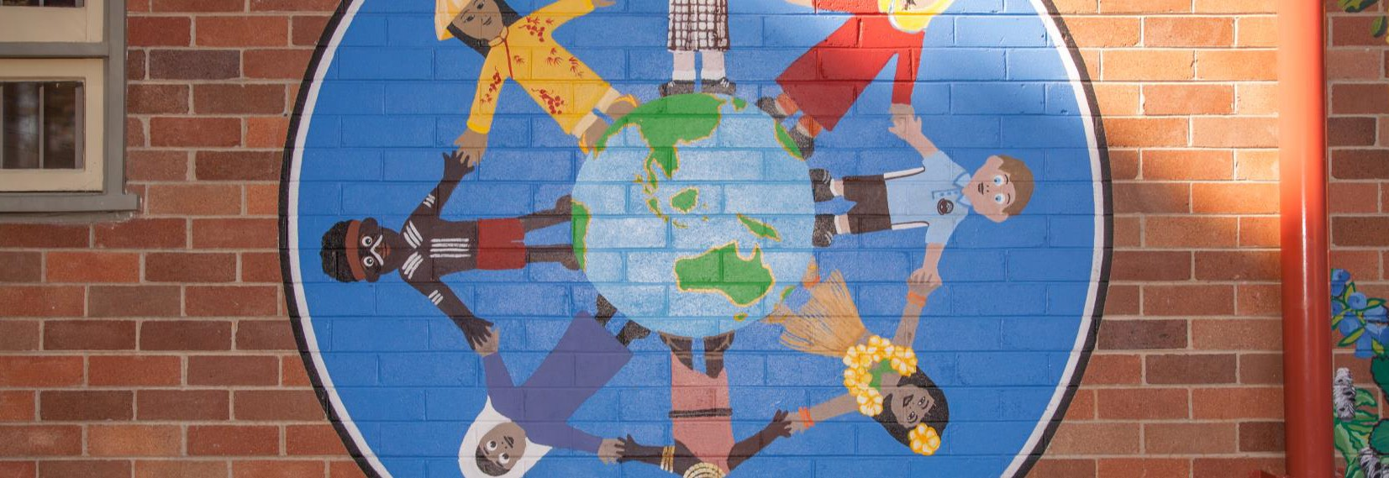
Community News
August
2018
Term 3 Week 3

Upcoming Dates
Monday 13 August - Science Week – Tree Planting with Bunnings
Tuesday 15 August - Science Incursion
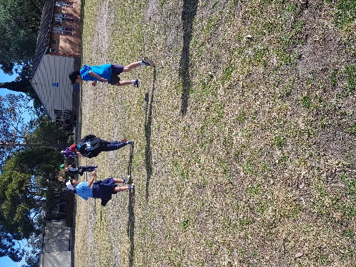
Monday 27 August – Athletics Carmnival
Wednesday 29 August - Class Book Week Activities
Thursday 30 August - Book Fair and Parade
Friday 31 August - Father’s Day Stall
Thursday 6 September – K-2 Excursion
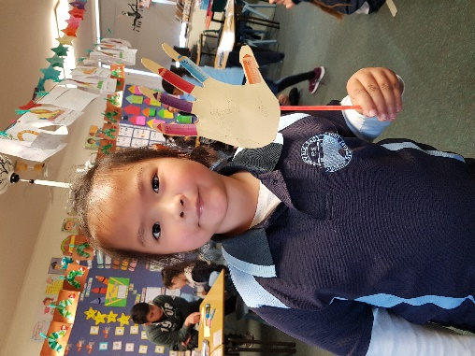
Principal Corner!
Welcome back to Term Three! It is shaping up to be an exciting term with lots of learning and opportunity.
I have had the opportunity to visit three classrooms and share their learning experiences. In Week One I visited K/1 Creative where I shared my favoutire book, Thelma the Unicorn. I then joined in their morning circle time, where students shared information about themselves with their peers. It was great to see students confidently talking to a large group. In Week 2, I was involved in a sport lesson with 5/6 Reflective. This lesson focussed on developing and enhancing skills to successfully engage in team sports. The focus was on resilience, acceptance, participation and leadership. Students successfully participated in a game of touch football, which was great to see.

This week I visited M Great where the students were engaging in spelling activities and news time. During news time the students discussed earthquakes and came up with research question around this topic. The students loved sharing their ideas and listening to others. Well done M Great!
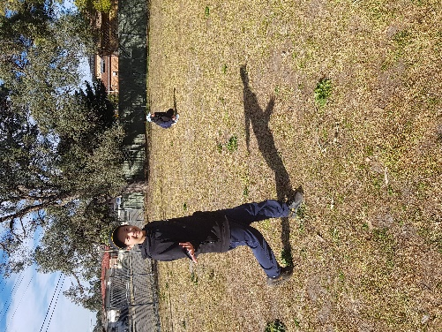

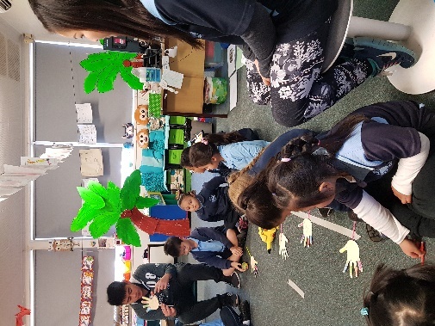

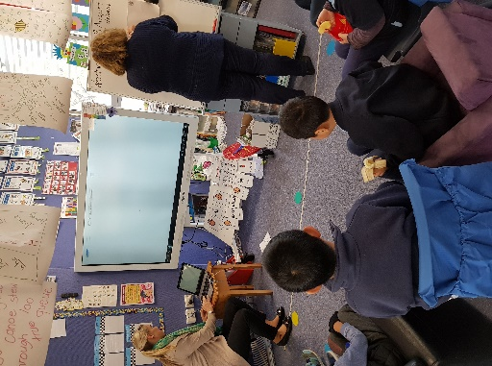
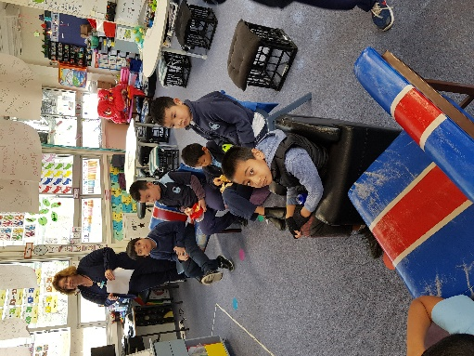

I would like to thank all the Lansvale East staff and community for making Education Week a great
Attendance
It is vital that students arrive to school on time. As soon as students arrive in the classroom, after assembly lines, student learning starts. The first part of the day involves teachers setting up routines for the day which contributes to successful learning that day! Then it is straight into lessons. Missing the first 5 -10 minutes of school equals a significant amount of missed learning time over the week or term. We understand that there might be circumstances that cause lateness and I encourage you to communicate with your child’s teacher for support.
School Pick Ups
School finishes at 3.00pm. It is important that students are picked up on time. Staff have important meetings in the afternoons so it makes it difficult if they still have students at school. We understand that things may happen on occasions. If you are going to be late picking up your children, can you please call the office so we are aware and can make arrangements. Thank you for your assistance with this matter.
Education Week – Multicultural Day
What a fabulous day was had by all, such a rich day of learning about different cultures. At Lansvale East we embrace all cultures and this day provided a rich opportunity for our students and families to learn about different cultures and celerbate their own. The students particpated in a range of workshops - Fijian, Vietnamese, Spanish, Asutralian, Middle Eastern and Aboriginal. Students learnt about traditional dances, costumes, food, practices, instruments, dress, customs, langauge and the geography of the different countires. Stories and music were also shared. Thank you Mrs Haggett for organising such a wonderful day for our community. A big thank you also to our families who supported the staff to deliver the workshops and those who visited during the day!

Education Week – Education Day
The day started off with a celebration of student achievments in the acdemic and creative arts areas. Student dance and choir performaces were outstanding. The dance performances were full of energy and colour and the choir sang beautifully! The band lead by Mr Yong performed with grace and confidence. Thank you Mrs Gibson, Miss Hall, Mr Yong and Mrs Pham for their leadership of the performance groups. It was also great to have Canley Vale High School student perform. The students loved the singing and ukulele playing. Following the assembly, families visited the classrooms and had a yummy sausage sizzle for lunch. After lunch, families particpated in their children’s learning. The children loved sharing and celebrating their work! Thank you Mrs Gibson for organising this great event and all the teachers and families for their support in making this such a wonderful day!
Zoo Excursion
The last week of Term Two school saw students visit the zoo! The students particpated in a lesson with a zoo keeper, where they learnt about a range of different reptiles and even got to touch them! They tocuhed lizards, turtles and snakes. Groups then visited different areas of the zoo where they saw polar bears, tigers, elephants, penguins, giraffes and more. A great day was had by all. A big thank you to all the teachers and Mrs Gibson and Mrs Rajsombath who were lead organisers of the day.
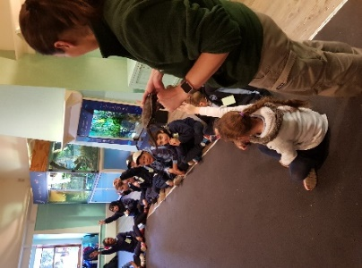
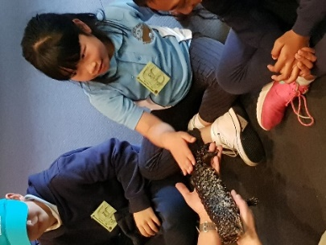

Term 2, Week 10 Assembly
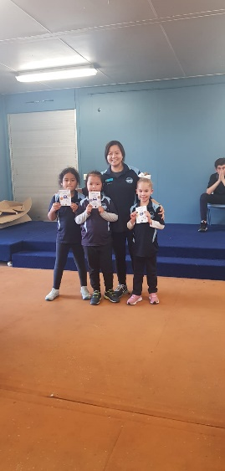
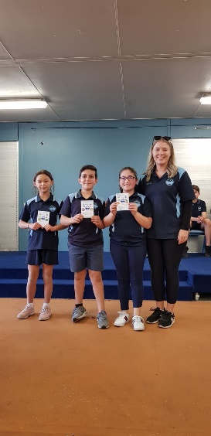
Congratulations to the student leaders on hosting the school assembly. It was fabulous to see so many students receiving class awards for great learning and following the school values. Miss Cameron was excited to announce the quality learner winners. We know those letters boxes will be getting very full over the next few weeks. Kinder Curious’ singing was delightful! They had definitely worked hard to present a great item. Well done!

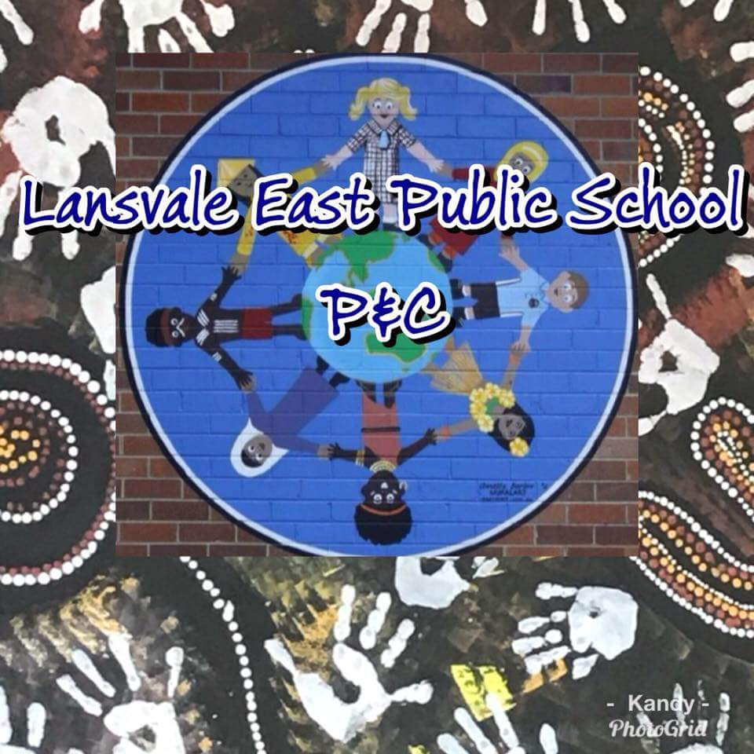

Learner Qualities in the Classroom
During 2018 we are embedding our new 3R core values (Respectful, Responsible and Resilient) and our 5 learner qualities (Optimistic, Brave, Curious, Reflective and Collaborative). We would like to share what being brave means to the students.
Brave – Having courage to engage in new and challenging experiences and difficult situations. At Lansvale East Public School students are supported by staff to face challenges and reflect on the skills they used to do this. We also celebrate their succusses in doing this in all aspects of their school life!
Riverside Parking
Riverside Road is extremely busy during school times, particualrly in the morning and afternoon. It is important that cars do not block any driveways at anytime. Residents need to have access to their driveways at all times. This also ensures the safety of all.
Carpark Construction Works
Construction is continuing at the front of the school. Work is proceeding well and we should soon have a new roundabout. Staff are still entering the school through the Jupiter Street entry. Please continue to use the pedestrian access at all times to ensure the safety of everyone.
Lansvale East P&C Facebook Page
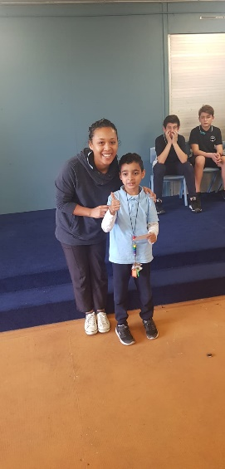
The Lansvale East P&C have created a Facebook page for our community. This page will provide current information relating to the P&C, including updates on activities, events and fundraisers. Please join up to get regular updates and information about how to become involved. To do this, search for Lansvale East P&C in the search engine of Facebook and click to join the group!

Notes
Reminders for excursions and incursions will be sent out a number of times. Things are very busy so these notes will help us to remember. The first run of notes will be on white paper. The next will be green and the third reminder will be on red. If you receive a green or red note and already have signed and or paid for the activity please confirm this at office.
Have a great few weeks!
Miss Nicole Cameron
Relieving Principal

